(Approx. 770 words)
Musings of an Apple Tyro
By Lorrin R. Garson, Potomac Area Technology and Computer Society
May 2017 issue, PATACS Posts
www.patacs.org
newslettercolumnist (at) patacs.org
The Demise of Windows Vista
On April 11th, Microsoft stopped all support for Windows Vista. This means no more security or online technical content updates from Microsoft. See http://bit.ly/2n5zJDv and http://bit.ly/2mzztJh. If you are still using Vista… you know the old saw about skating on thin ice. Microsoft will cease support for Windows 7 (Service Pack 1) on January 14, 2020; see http://bit.ly/2ngOvba.


Aging Mac Computers

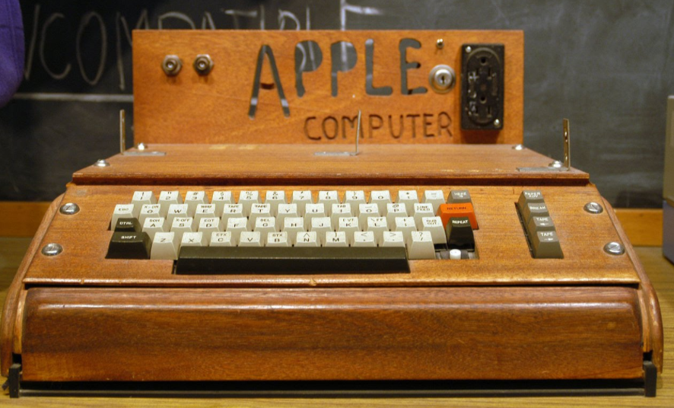
In the last year or so, Apple has largely focused on the iPhone, iPad and Apple Watch—not Mac computers. Shown in Table 1 are the number of days (also expressed in years) since various models of Apple computers have been refreshed. This is as of March 18, 2017. Hopefully we will soon see this situation remedied. Apple computers are falling behind. See https://imac.macrumors.com.
Table 1: Time (days and years) Since Last Refreshed
Computer  Model | Number of  Days | Number of  Years
iMac | 523 | 1.4
MacBook Air | 741 | 2.0
Mac Mini | 885 | 2.4
Mac Pro | 1,187 | 3.3
Interestingly, Seamus Bellamy, writing in PC World, has decided to abandon his Mac for a PC (see http://bit.ly/2nvWwGH; see also http://bit.ly/2mSYhPG). One of his numerous complaints is Apple’s aging computers. See Seamus’ article in PC World entitled “Switching from Mac to PC: Choosing a laptop”; see http://bit.ly/2nze9W4. Bear in mind PC World is generally more favorable toward Microsoft than Apple. It will be interesting to see how this plays out.
Update to macOS Sierra
In early March macOS Sierra 10.12.4 beta 5 was released to developers and public beta testers. Changes to Siri, Dictation, and Apple’s PDF API are expected. Night Shift, which is currently available on iOS devices, will be introduced to Mac computers. Night Shift, which adjusts the color of display after sunset reducing bright blue light that can adversely impact human circadian rhythms and make it harder to sleep, will be introduced to Mac computers. Other changes can be expected but this will not be a major OS update.
MacBook Pro Battery Stamina
Apple claims the battery in this laptop will last up to 10 hours (see http://apple.co/2nza3Ag), but there has been grumbling that it doesn’t last anywhere near that long. It turns out that with intensive GPU/CPU use the battery lasts around 80 minutes. For details, see http://bit.ly/2jKUzmm.
Google Chrome
If you use the Chrome Browser, look at http://bit.ly/2kAoYom. This article in PCWorld is entitled “10 Frustrating Google Chrome Irritations and How to Fix Them”. But there’s more than that—there are workarounds on how to mitigate some of these limitations.
Quantum Computers
Quantum computing is in the news these days. What is it, other than being mysterious and quirky? In classical computing a “bit” can have two states: “0” or “1”… “yes” or “no”, “on” or “off”, etc. In quantum computing, a “qbit” (aka “qubit”) can have three states “0”, “1” and “0 and 1” simultaneously. Quantum computing is based on quantum mechanics that began with Albert Einstein, Max Planck and other giants of physics in the early 1900’s. Why does it matter? Quantum computing has enormous potential for drug design, weather forecasting, communications, “big data” analysis, traffic control and other areas that require massive computer power. The March 11th-17th issue of The Economist features quantum computing (p.11 and the special section following p. 44, entitled “Here, there and everywhere”). Also see, as examples, http://bit.ly/2nr7PTL, http://bit.ly/2mvYKnq, and http://bit.ly/2mMANdw. Don’t expect to have a quantum computer on your desktop or in a tablet anytime soon, but you don’t need it for surfing the Web, email and controlling your garage door.
One Bit on One Atom
On current hard disk drives it takes about 100,000 atoms to store one bit of information. Scientists at IBM’s Almaden Lab in San Jose, California have achieved the ultimate. They have managed to store one bit of data on a single magnetized atom of Holmium (Ho). Don’t expect to buy a disk drive using this technology at Micro Center anytime soon. It’s strictly experimental. See http://bit.ly/2mxDA9A.
Ransomware on Dramatic Rise
According to articles from PC World (see http://bit.ly/2mC6tBw) and CIO (see http://bit.ly/2mQ1g9O), Ransomware attacks rose from 3.8 million in 2015 to 638 million in 2016. The article in PC World contains good advice on how to prevent such attacks and what to do if you get hit.
KrebsOnSecurity
From time to time I have commented on KrebsOnSecurity (https://krebsonsecurity.com/) as an excellent source for information on current security issues. It makes for chilling reading, but I strongly recommend periodic reading of this Web site.

